Week 5 Written Report

By Yaoqi Lei, Haechan Jung, Yuhang Mao

The report is to figure out the orbital velocity of an object that rotates around Milky Way.

To calculate orbital velocity, we use the orbital velocity formular V=(GM/R)^(1/2), which G means gravitational constant; M means mass of an object; R means the distance between an object and the center of a galaxy, also as known as radius.

To calculate the velocity of an object that rotates around Milky Way, we use enclosed mass as M, the distance between an object and the center of Milky Way as R. Enclosed mass means the amount of mass contained in the space covered from the center of the galaxy to the object, which equal to density times enclosed volume. To calculate enclosed mass, we need to know the mass of the galaxy and shape of the galaxy first. The Milky Way can be simply divided into three parts, bulge, disk and halo. The shape of Disk can be seen as a circle. The shape of bulge and halo can be seen as a small sphere and a big sphere. So the density of disk equal to M/(Pi\*r^2), density of bulge equal to M/((3/4)\*Pi\*r^3) which 0<r<10kpc, density of halo equal to M/((3/4)\*Pi\*r^3). After we get the enclosed density, we use the radius to calculate the enclosed mass of each component. Then we put the all the data we get back to the orbital velocity formular to each component.

Then we get blue line that represent orbital velocity component of disk, red line that represent orbital velocity component of bulge and yellow line represent orbital velocity component of halo. Adding up all of the three components, the sum that we get is purple line, the orbital velocity of an object in Milky Way. It is fix to the given data (black dots).

The shape of the black line that we get is a line sharply decrease at first, then increase from about 2.5 kpc to 10 kpc. Velocity peak at 10 kpc over 250 km/s. Then the velocity continues decrease with a slower and slower rate of change. It starts to increase at the end.

The orbital velocity line decreases at first because a lot of velocity proved by the bulge when the object is near to the center of the Milky Way. At about 2.5 kpc away from the center of the Milky Way the disk (blue line) component is over the bulge (red line) component. So, the orbital velocity line starts to increase. It peaks at 10 kpc then decrease again, because the main effect components of this part is disk (blue line) that decrease slowly and halo (yellow line) that increase at a constant speed.

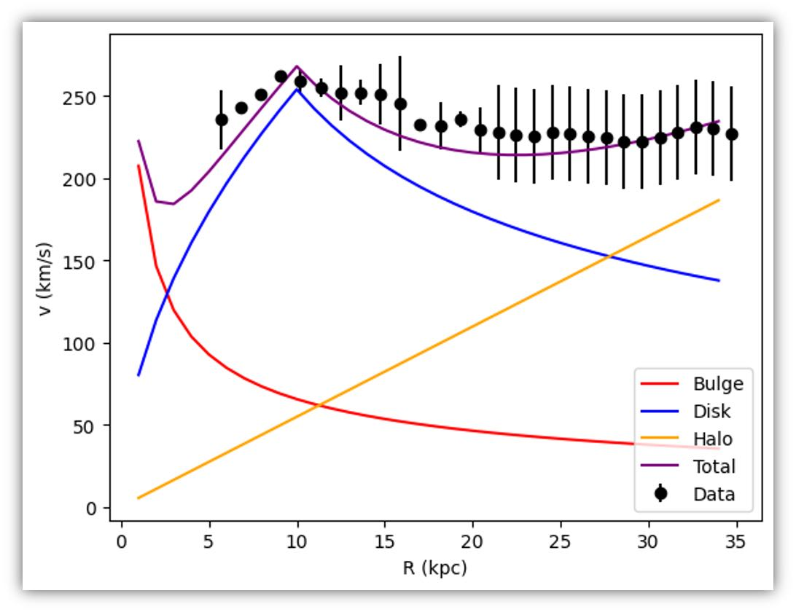

There is a gap between total and actual data. We can assume the gap represents dark matter.

Contribution statement

The three of us each finished a code. Because there seems to be a problem with Lei's code data, the result is significantly lower than predicted. The Mao code range from 30 to 35kpc cannot be drawn. So, we finally decided to use Jung's code for the report. The PowerPoint for the Presentation was done by Jung. Written reports are done by Lei. Mao played an irreplaceable role in the debug link.

Mao’s code:

<https://github.com/Stocal723/Astronomy-project1/blob/main/calculating_the_Rotation_curve_of_Milky_Way.ipynb>

Jung’s code:

<https://github.com/Stocal723/Astronomy-project1/blob/main/calculating_the_Rotation_curve_of_Milky_Way.ipynb>

Lei’s code:

https://github.com/RedBull-Astronomy/lei.440/blob/main/Untitled2.ipynb

AI statement:

We used Gemini when coding.